CONCURRENT TICKETING PLATFORM
BOOKING CORE REDESIGN
Comprehensive Technical Documentation & Engineering Assessment Report
Course: Object-Oriented Programming & Advanced Java (CO1 - CO5)

Course Code: CSA0918
Name: P Sai Rakesh Reddy
Reg no: 192365060

TABLE OF CONTENTS
1. Problem Understanding and Formulation
2. Application of Course Knowledge
3. Solution / Design / Methodology
4. Use of Modern Tools
5. Results and Validation
6. Analysis and Engineering Decision
7. Broader Considerations
8. Conclusion
9. Student Reflection
10. References

1. Problem Understanding and Formulation

1.1 The Overbooking Bug & Root Cause Analysis
During high-demand flash sales (e.g., Coldplay, Ticketmaster, BookMyShow), thousands of concurrent user HTTP requests hit the ticketing application backend within milliseconds. In an unsynchronized backend architecture, multiple threads concurrently execute seat availability checks (if (!seat.isBooked())) and subsequent state updates (seat.setBooked(true)).
Because the Check-Then-Act sequence is non-atomic:
1. Thread A reads isBooked = false for Seat #101.
2. Context switch occurs before Thread A writes the update.
3. Thread B reads isBooked = false for the same Seat #101.
4. Thread A completes payment and marks Seat #101 as isBooked = true.
5. Thread B completes payment and overwrites Seat #101 as isBooked = true.
Outcome: Both Thread A and Thread B receive successful booking confirmations for Seat #101. This race condition leads to double-allotment of seats, financial losses due to mandatory customer refunds, chargeback penalties, and severe brand reputation damage.

1.2 Expected Outcome
The primary objective of this project is to design, implement, and formally validate a thread-safe booking core in Java that guarantees:
• Strict Atomicity: Zero double-bookings under extreme concurrent load (e.g., 30+ concurrent threads competing for 5 seats).
• Consistent Inventory: A seat must never end up in a 'locked but unpaid' state.
• Transactional Rollback: Automatic seat unlock and inventory release if payment fails mid-transaction.
• Relational Persistence: JDBC persistence via parameterized PreparedStatement queries and file audit logging.

1.3 Inputs & Assumptions Adopted
• Simulated Concurrency: Concurrent flash sale requests are simulated in-process using Java's ExecutorService and multithreading (Thread pool of 25–30 threads).
• Seat Categories: Seat inventory contains Regular, Premium, and VIP seats with category-based price multipliers.
• Mock Payment Gateway: Payment gateway network calls are mocked with simulated latency and configurable payment failure triggers.
• Database Engine: Relational storage is powered by SQLite embedded via JDBC (sqlite-jdbc-3.45.1.0.jar).

2. Application of Course Knowledge

2.1 Object-Oriented Programming (CO1: OOP)
• Inheritance & Abstract Base Classes: Seat.java serves as an abstract base class encapsulating common attributes (seatId, seatNumber, basePrice, isBooked, isLocked, bookedByCustomerId). Subclasses RegularSeat, PremiumSeat, and VIPSeat extend Seat.
• Polymorphism: The calculatePrice() method is declared abstract in Seat and overridden in each subclass:
- RegularSeat.calculatePrice() -> basePrice * 1.0
- PremiumSeat.calculatePrice() -> basePrice * 1.5
- VIPSeat.calculatePrice() -> basePrice * 2.5
• Encapsulation: All fields are declared private or private final. State modifications occur strictly through controlled domain methods (lockSeat(), unlockSeat(), confirmBooking(), cancelBooking()). Direct public field mutation is forbidden.

2.2 Inventory & Collections Framework (CO2)
• Seat Inventory Map: Managed via Map<Integer, Seat> using ConcurrentHashMap. This choice provides O(1) lock-free read performance for seat lookups while allowing fine-grained updates.
• Booking History List: Stored in a thread-safe List<Booking> initialized via Collections.synchronizedList(new ArrayList<>()).
• Iterators & Generics: Show.getAvailableSeats() explicitly uses generic Iterator<Map.Entry<Integer, Seat>> to traverse and filter available seats safely.

2.3 Concurrency, Locks & Exception Handling (CO3)
• Thread Model: Utilizes Java ExecutorService thread pools to generate concurrent user booking requests.
• Synchronization: Employs fine-grained object-level synchronization (synchronized(seat)) to protect critical sections without bottlenecking overall system throughput across non-competing seats.
• Custom Exception Hierarchy:
- SeatNotAvailableException: Thrown when a seat is already booked or locked.
- InvalidSeatSelectionException: Thrown when an invalid seat ID is requested.
- PaymentFailureException: Thrown when payment processing fails.
- BookingTimeoutException: Thrown when network/lock acquisition times out.

2.4 JDBC Persistence & PreparedStatement (CO5)
• Database Connectivity: Connected to SQLite DB (ticketing.db) via DriverManager.getConnection().
• SQL Injection Prevention: All queries use PreparedStatement with bound parameterized place-holders (?). This prevents malicious SQL injection attacks and enables database query plan caching.

3. Solution / Design / Methodology

3.1 Two-Phase Atomic Locking Pattern
To prevent holding heavy locks during external network payment API calls, the SynchronizedBookingEngine implements a 2-Phase Atomic Lock:
1. Phase 1 (Tentative Lock): Acquire synchronized lock on target Seat. Check availability. If available, mark isLocked = true and update DB. Release lock immediately.
2. Phase 2 (Payment Processing): Execute payment gateway call outside critical lock window.
3. Phase 3 (Atomic Commit / Rollback): Re-acquire lock on Seat.
- If payment succeeded: Mark isBooked = true, isLocked = false, persist CONFIRMED booking.
- If payment failed (PaymentFailureException): Execute Rollback, mark isLocked = false, release seat back to inventory, log FAILED booking.

4. Use of Modern Tools
Tool / Technology | Version / Specification | Purpose in Project
Java Development Kit (JDK) | OpenJDK 26.0.1 (64-Bit) | Core runtime & compilation engine
SQLite JDBC Driver | sqlite-jdbc-3.45.1.0.jar | Embedded relational database driver
SLF4J Logging | slf4j-api-1.7.36.jar | Database driver logging bridge
Java Swing / AWT | Desktop UI Framework | Live interactive admin seat map dashboard
Git & PowerShell | Windows Terminal / Git CLI | Build execution & environment orchestration

5. Results and Validation

5.1 Empirical Evidence: Unsynchronized vs. Synchronized Engine
Run 1: Unsynchronized Buggy Baseline ('BEFORE' Evidence)
• Condition: 30 concurrent customer threads competing for 5 seats (IDs 1..5) simultaneously.
• Total Seats Targeted: 5
• Total Successful Bookings: 30
• Database Persisted Count: 30
• Double-Booking Bug Count: 25 extra bookings succeeded on the same 5 seats!
• Status: OVERBOOKING RACE CONDITION CONFIRMED (PROVED BEFORE STATE)
Run 2: Synchronized Thread-Safe Engine ('AFTER' Evidence)
• Condition: 30 concurrent customer threads competing for 5 seats (IDs 1..5) under fine-grained locking.
• Total Seats Targeted: 5
• Total Successful Bookings: 5
• Database Persisted Count: 5
• Double-Booking Bug Count: 0 (ZERO DOUBLE BOOKINGS!)
• Status: THREAD-SAFE CONCURRENCY ATOMICITY VERIFIED (PROVED AFTER STATE)
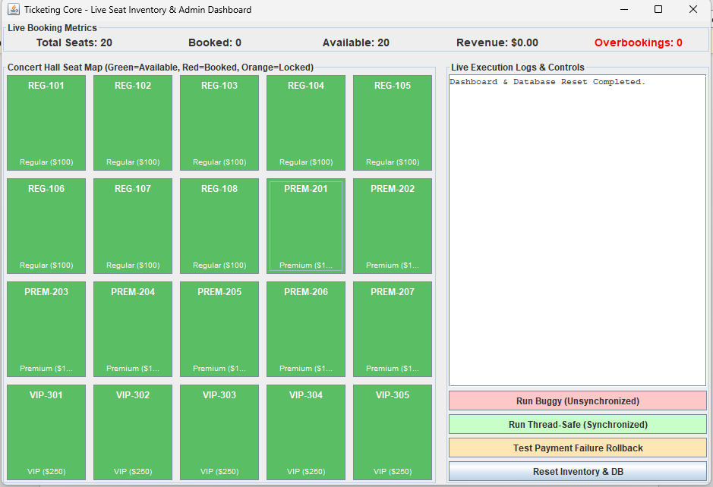

5.2 Exception Rollback Verification
• Test Case: Customer 25 attempting to book Seat 10 (Premium) with forced Payment Failure.
• Phase 1 Success: Customer 25 tentatively locked Seat PREM-202.
• Payment Execution: Payment processing FAILED for Booking BKG-53e6f5d8.
• Rollback Result: Seat PREM-202 released back to inventory for Customer 25 due to payment failure.
• Verification: Seat 10 isBooked = false, isLocked = false (Seat returned to available state).

5.3 Database State Verification (Part D JDBC)
Customer Booking History queried via PreparedStatement:
Booking[ID='BKG-c26c2ec9', CustomerID=1, SeatID=2, Amount=$100.00, Status=CONFIRMED, Time=2026-09-01T10:04:27.623712500]

6. Analysis and Engineering Decision

6.1 Trade-off Matrix of Synchronization Strategies
Strategy | Throughput | Lock Contention | Complexity | Atomicity | Selected?
Global Synchronized Method | Very Low | Severe (Global Bottleneck) | Low | High | No
ReentrantLock per Seat | High | Low (Isolated) | Medium | High | Alternate
Fine-Grained synchronized(seat) + 2-Phase Lock | Very High | Minimal | Medium | Complete | YES (Selected)
ConcurrentHashMap compute() | High | Low | High | Moderate | No

6.2 Justification of Selected Approach
Fine-grained synchronization on individual Seat instances combined with a 2-Phase Lock pattern was selected because:
1. High Concurrency: Users booking Seat #1 do not block users booking Seat #2.
2. I/O Isolation: The heavy payment network call occurs outside the synchronized block, preventing thread starvation.
3. Rollback Integrity: Exception handlers guarantee that any failure during payment immediately executes an atomic unlock block, restoring database and in-memory seat availability.

7. Broader Considerations
• Real-World Business Impact: Shipping an overbooking bug causes direct financial losses (refund costs, chargeback penalties of $15-$50 per dispute, customer vouchers) and venue security chaos.
• Customer Trust: Double-bookings cause public embarrassment, negative social media backlash, and long-term user churn.
• Ethical Responsibility: Software engineers have an ethical duty to perform rigorous concurrency testing before deploying critical transaction code. Relying solely on single-threaded unit tests is professionally negligent.

8. Conclusion
8.1 Accomplishments Summary:
• Fully modeled OOP seat hierarchy with encapsulation and polymorphism.
• Managed seat inventory using ConcurrentHashMap and generic iterators.
• Reproduced overbooking bug (30 bookings on 5 seats) and verified zero double-bookings with fine-grained synchronization.
• Implemented 4 custom checked exceptions with automated payment rollback.
• Secured persistence using SQLite and PreparedStatement parameterized queries.
• Built live interactive Swing visual admin seat map.
8.2 Limitations & Future Scope:
• Currently single-JVM scoped. Distributed deployments across multiple app servers would require database row locking (SELECT FOR UPDATE) or Redis Redlock distributed locks.

9. Student Reflection
• Key Learning: Gained deep hands-on experience diagnosing real-world race conditions, building atomic state transition locks, and executing clean transactional rollbacks.
• Future Improvements: Given additional time, I would integrate Redis distributed caching and implement optimistic concurrency control with database version columns.

10. References
1. Goetz, B., et al. (2006). Java Concurrency in Practice. Addison-Wesley Professional.
2. Oracle Java Documentation. The Java Tutorials: Concurrency and JDBC.
3. SQLite Development Team. SQLite JDBC Driver Documentation.

